REPORT OF ANALYSIS DONE

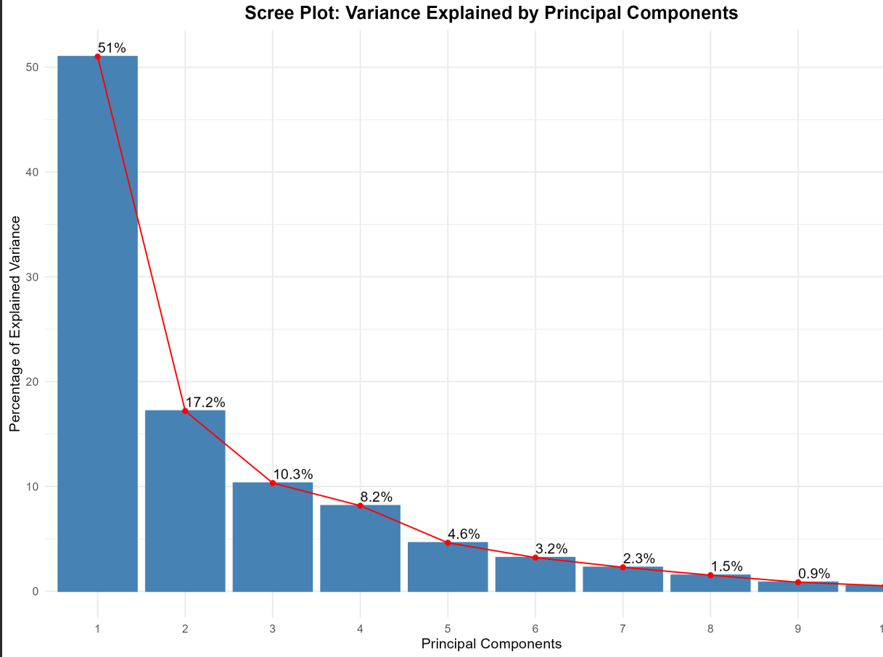
Figure 1: variance explained by each principal component

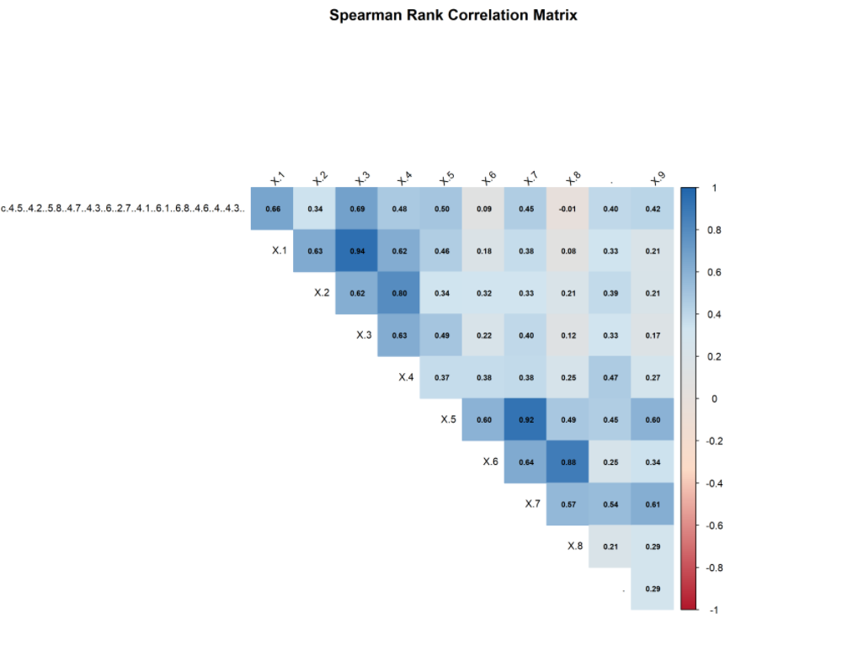
Figure 2: Spearson correlation report
The correlation analysis reveals the direction and intensity of the correlations between the morphometric characteristics. While negative correlations imply conflicting patterns or trade-offs, positive correlations show features that tend to rise together. The use of PCA to reduce dimensionality and summarize the main variance in the data is supported by the significant correlations.

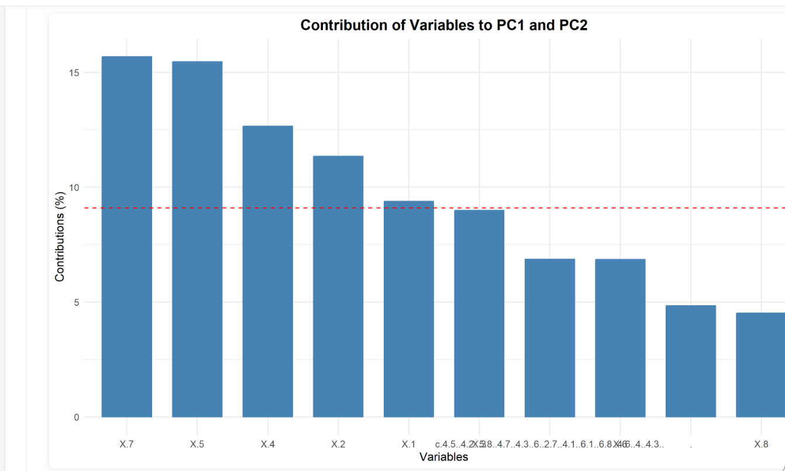
Figure 3: variance showing the principal component
The PCA showed that the first three principal components account for 78.5% of the total variance.
- PC1 explains 51% of variance
- PC2 explains 17.2% of variance
- PC3 explains 10.3% of variance

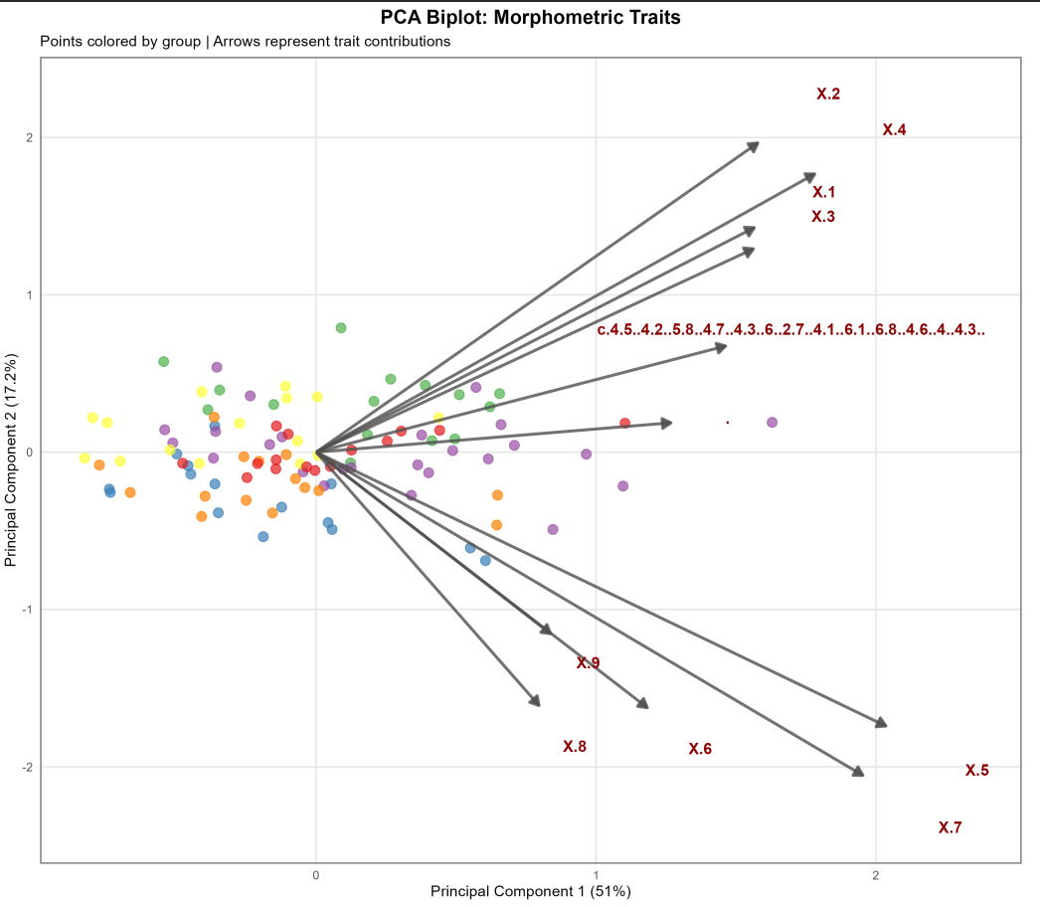
Figure 4: PCA biplot without confidence ellipses
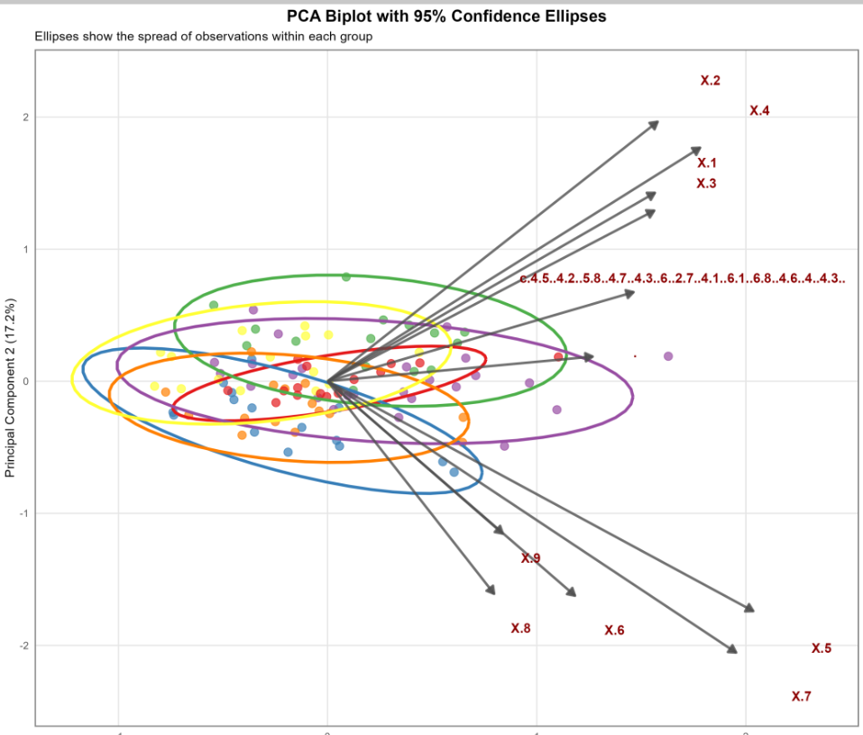
Figure 5: 95% confidence ellipses of the PCA biplot

The PCA biplots with 95% confidence ellipses illustrate how distinctly the groups are separated.
- Á vs Ã: Overlapping (distance = 0.39 units)
- Á vs È: Overlapping (distance = 0.33 units)
- Á vs Ë: Overlapping (distance = 0.21 units)
- Á vs Î: Overlapping (distance = 0.29 units)
- Á vs Õ: Overlapping (distance = 0.38 units)
- Ã vs È: Overlapping (distance = 0.72 units)
- Ã vs Ë: Overlapping (distance = 0.56 units)
- Ã vs Î: Overlapping (distance = 0.11 units)
- Ã vs Õ: Overlapping (distance = 0.45 units)

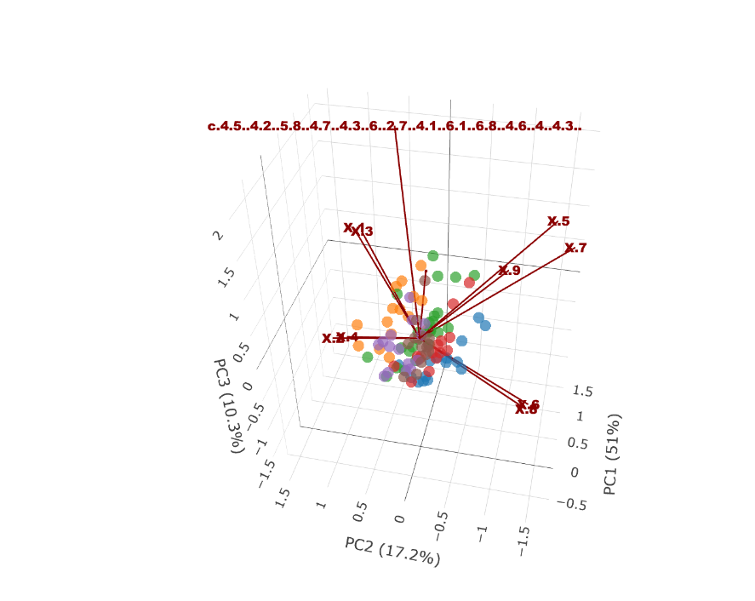
Figure 6: Interaction of the data through 3D visualization
The shape variation across the sample is displayed here, with PC1 accounting for 51%, PC2 for 17.2%, and PC3 for 10.3% of the overall variance, which together account for about 80% of the morphological variation. The variable vectors (x1–x9) show how each feature contributes to the separation; x2 and x4 primarily shape the PC1/PC2 pattern, x6, x7, and x8 point in the opposite direction, and x9 contributes significantly along PC3. The samples cluster close to the center. In the analysis, these characteristics seem to be the primary forces behind morphological difference.

